**EX.NO: 10 REGISTER NO: 210701284**

**DATE:**

**VISUALIZE DATA USING ANY PLOTTING FRAMEWORK AIM:**

To visualize data using any plotting framework

**PROGRAM CODE:**

**SCATTER PLOT:**

# Install ggplot2 (if not already installed)

install.packages("ggplot2") # Load the ggplot2 package

library(ggplot2)

# Scatter plot of Sepal.Length vs Sepal.Width, colored by Species ggplot(data = iris, aes(x = Sepal.Length, y = Sepal.Width, color = Species)) + geom_point(size = 3) + # Adds points labs(title = "Scatter Plot of Sepal Dimensions", x = "Sepal Length (cm)",

y = "Sepal Width (cm)") + # Adds axis labels and title theme_minimal() # Applies a minimal theme

**BAR CHART:**

# Install ggplot2 (if not already installed)

install.packages("ggplot2") # Load the ggplot2 package library(ggplot2)

# Bar plot of Species counts ggplot(data = iris, aes(x = Species)) +

geom_bar(fill = "steelblue") + # Adds bars filled with steel blue color labs(title = "Count of Different Species in Iris Dataset", x = "Species", y = "Count") +

theme_minimal()

**HISTOGRAM**

# Install ggplot2 (if not already installed)

install.packages("ggplot2") # Load the ggplot2 package library(ggplot2)

# Histogram of Sepal Length

ggplot(data = iris, aes(x = Sepal.Length)) +

geom_histogram(binwidth = 0.3, fill = "orange", color = "black") + # Adds histogram bars labs(title = "Histogram of Sepal Length", x = "Sepal Length (cm)", y = "Frequency") +

theme_minimal()

**BOX PLOT**

# Install ggplot2 (if not already installed)

install.packages("ggplot2") # Load the ggplot2 package

library(ggplot2)

# Box plot of Sepal Length for each Species

ggplot(data = iris, aes(x = Species, y = Sepal.Length, fill = Species)) + geom_boxplot() + # Adds box plot

labs(title = "Box Plot of Sepal Length by Species", x = "Species",

y = "Sepal Length (cm)") +

theme_minimal()

**OUTPUT:**

**SCATTER PLOT:**

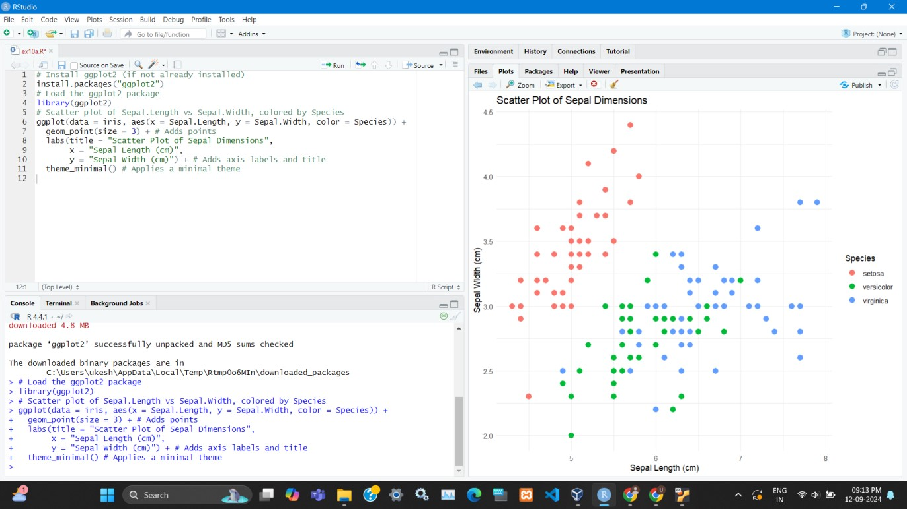

**BAR CHART:**

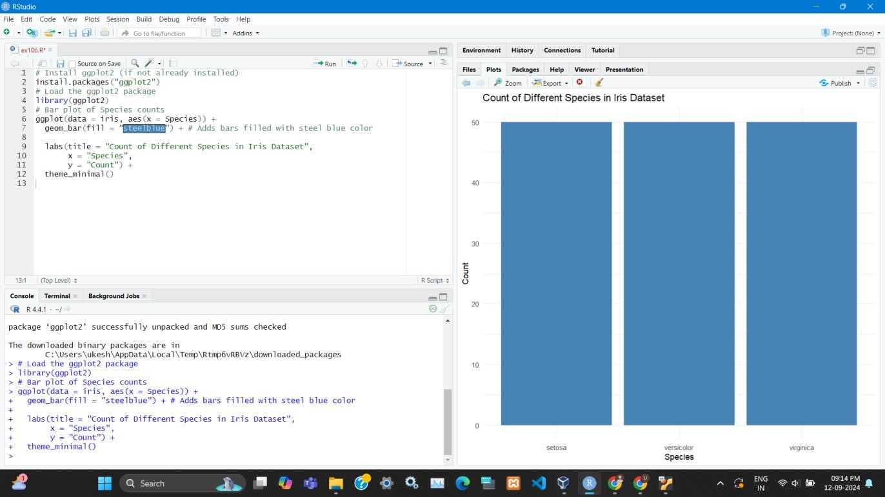

**HISTOGRAM**

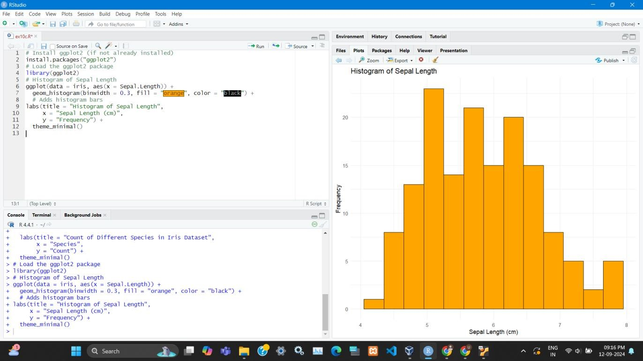

**BOX PLOT**

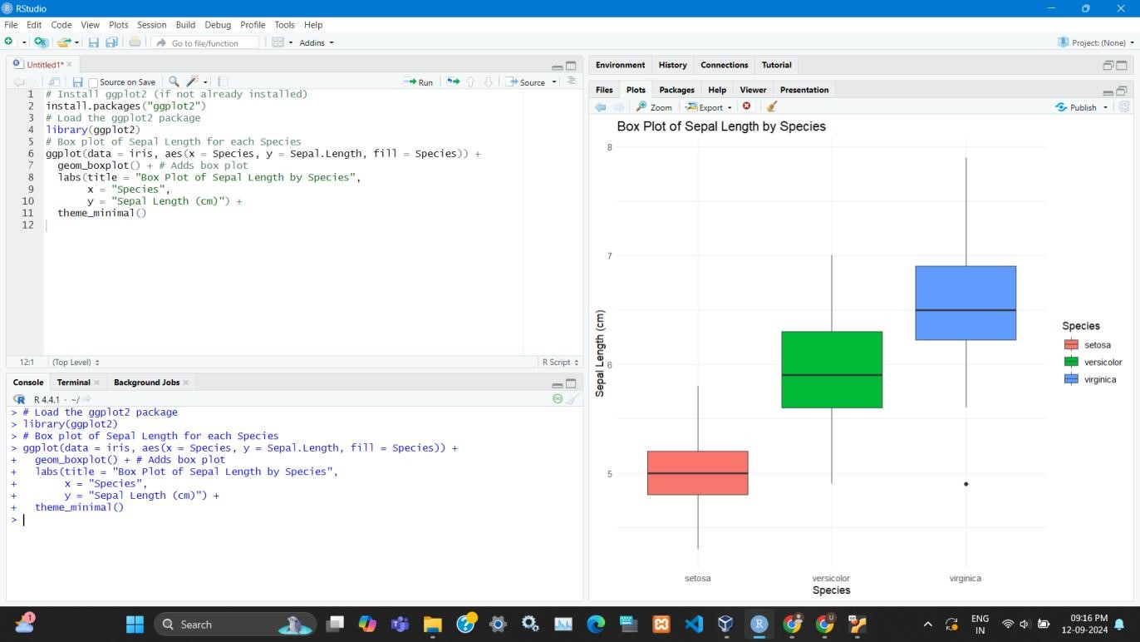

**RESULT:**

Thus the visualization of data using any plotting framework done successfully.